|  |  |  |
| --- | --- | --- |
|  | CUBE OF A NUMBER USING 8051 |  |
| Exp No.: 13 |  | **Name:** S Vishakan |
| Date: 21-10-2020 |  | **Reg. No:** 18 5001 196 |

**AIM:**

To write an assembly language program to calculate the cube of an 8-bit number using an 8051 microcontroller.

**PROGRAM – 1: CUBE OF A NUMBER:**

**ALGORITHM:**

1. Begin.
2. Initialize R0 with 00h.
3. Move the value in R1 to A.
4. Move the value in R1 to B.
5. Multiply A and B.
6. Move the value in R1 to B.
7. Multiply A and B.
8. Move B to R4 (MSB of cube) and A to R5 (LSB of cube)
9. End.

|  |  |
| --- | --- |
| **PROGRAM** | **COMMENTS** |
| MOV R0, #00 | R0 has address of 0x00 |
| MOV A, R1 | Transferring 8-bit number to reg A |
| MOV B, R1 | Transferring 8-bit number to reg B |
| MUL AB | BA = A x B |
|  | Since it is 8-bit B = 0x00 |
| MOV B, R1 | Transfer 8-bit value to B |
| MUL AB | BA = A x B |
| MOV R5, A | Moving lower byte to R5 |
| MOV R4, B | Moving higher byte to R4 |
|  |  |
| HALT: |  |
| SJMP HALT | Halt the program with a loop. |

**SAMPLE I/O SNAPSHOT:**

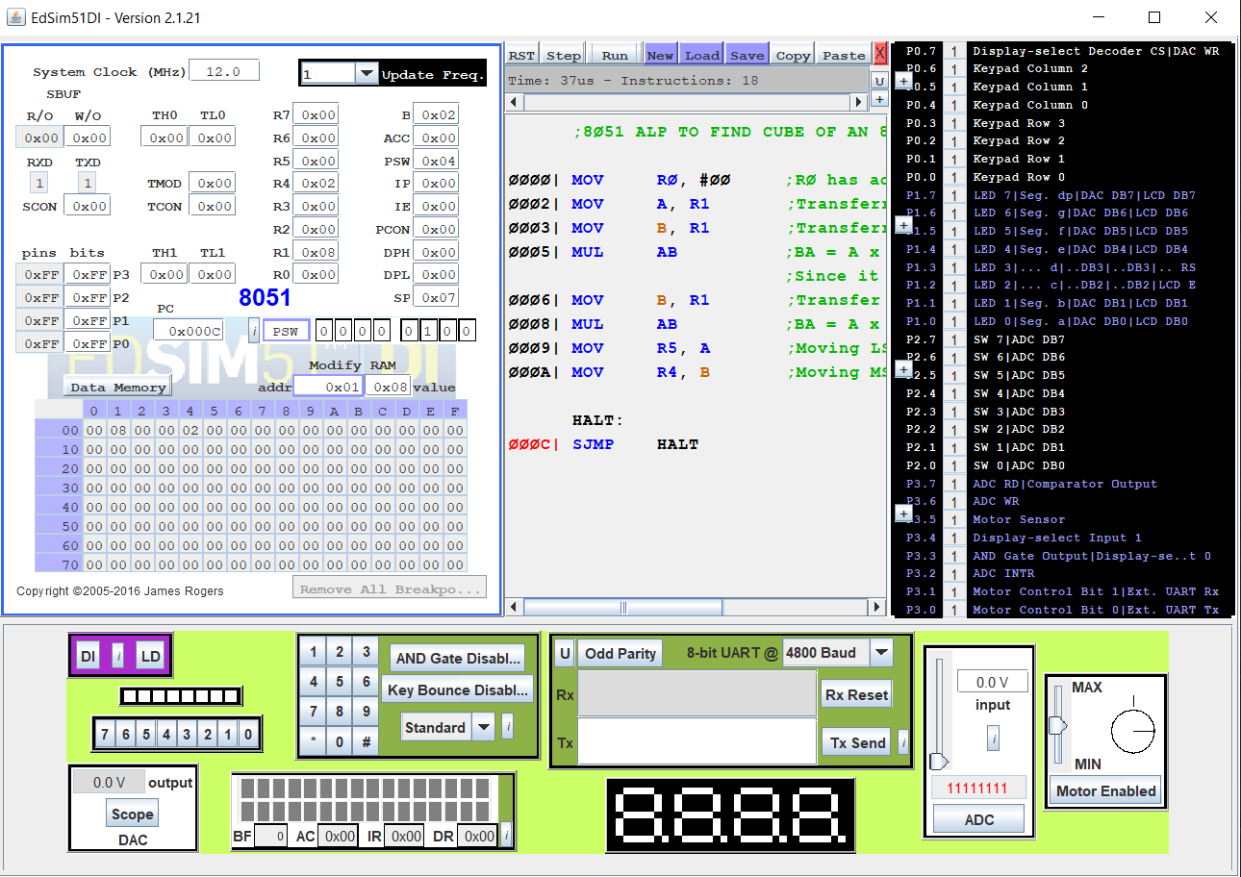

**RESULT:**

An assembly level program was written to calculate the cube of a given 8-bit number using an 8051 microcontroller and the output was verified.